**Assignment 02**

IP HEADER

**H**eader information at the beginning of an IP packet

**COMSATS University Islamabad**

Sahiwal Campus



**Usama Sarwar**

FA17-BS(CS)-090-B

**Dr. Majid Hussain**

Computer Communication & Networks

November 08, 2019

Table of Contents

1. IP Header 1

1.1 Version 1

1.2 Header length 1

1.3 Priority and Type of Service 1

1.4 Total length 1

1.5 Identification 1

1.6 Flags 1

1.7 Fragmented offset 1

1.8 Time to live 1

1.9 Protocol 2

1.10 Header checksum 2

1.11 Source IP address 2

1.12 Destination IP address 2

1.13 Options 2

IP HEADER

Header information at the beginning of an IP packet

# IP Header

An **IP header** is a prefix to an IP packet that contains information about the IP version, length of the packet, source and destination IP addresses, etc. It consists of the following fields:

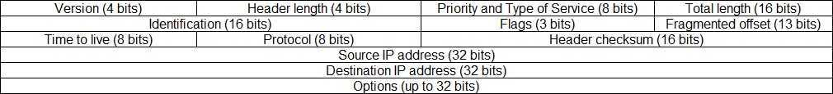

Here is a description of each field:

## Version

The version of the IP protocol. For IPv4, this field has a value of 4.

## Header length

The length of the header in 32-bit words. The minimum value is 20 bytes, and the maximum value is 60 bytes.

## Priority and Type of Service

Specifies how the datagram should be handled. The first 3 bits are the priority bits.

## Total length

The length of the entire packet (header + data). The minimum length is 20 bytes, and the maximum is 65,535 bytes.

## Identification

Used to differentiate fragmented packets from different datagrams.

## Flags

Used to control or identify fragments.

## Fragmented offset

Used for fragmentation and reassembly if the packet is too large to put in a frame.

## Time to live

Limits a datagram’s lifetime. If the packet doesn’t get to its destination before the TTL expires, it is discarded.

## Protocol

Defines the protocol used in the data portion of the IP datagram. For example, TCP is represented by the number 6 and UDP by 17.

## Header checksum

Used for error-checking of the header. If a packet arrives at a router and the router calculates a different checksum than the one specified in this field, the packet will be discarded.

## Source IP address

The IP address of the host that sent the packet.

## Destination IP address

The IP address of the host that should receive the packet.

## Options

Used for network testing, debugging, security, and more. This field is usually empty.

